Questions:

1. AlterthetableSTUDENTwithfollowingstructure.

|  |  |  |
| --- | --- | --- |
| # | Column | Constraints |
| Name |
| 1 | RegNo | PRIMARY |
| KEY |
| 2 | MobileNo | NOTNULL |

1. AlterthetablenameFACULTYwithfollowingstructure.TheDeptNointhistablereferstheDeptNointheDEPARTMENT table.

|  |  |  |  |
| --- | --- | --- | --- |
|  | Column |  | Constraints |
| # | Name |  |  |
|  | FacNo |  | PRIMARY |
| 1 |  | KEY |
|  | Gender |  | CHECK |
| 2 |  | ‘M’or‘F’ |
| 3) | AftertheFACULTYtableissuccessfullycreated,testifyoucanaddaconstraint | | |
| FOREIGNKEYtotheDeptNoofthistable. | | | |
| 4) | Alterthe tablenameDEPARTMENTwithfollowingstructure. | | |
|  | Column |  | Constraint |
| # | Name |  |  |
|  | DeptNo |  | PRIMARY |
| 1 |  | KEY |
| 5) | AlterthetablenameCOURSEwithfollowingstructure. | | |
|  | Column |  | Constraint |
| # | Name |  |  |
|  | CourseNo |  | PRIMARY |
| 1 |  | KEY |
| 2 | SemNo |  | 1to6 |

1)

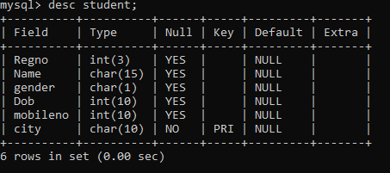

2)

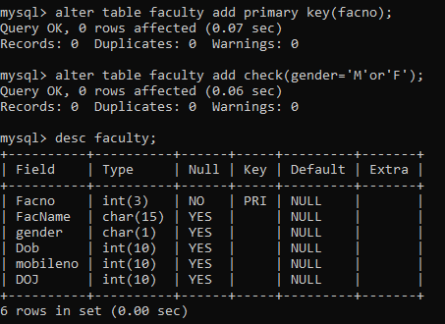

4)

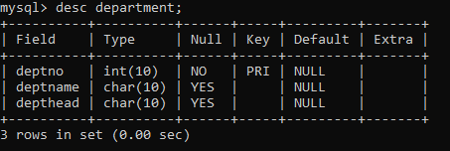

5)

